Reverse Mortgage Social Media Post: Weighed down by multiple debt payments?
________________________________________________________________________________

Caption
Ease your financial burden in retirement with a reverse mortgage.
Not only can you use your tax-free funds to pay off your existing mortgage, credit cards, and more—you get the added bonus of no monthly payments.
Curious about how you can pay down debt and enjoy freedom from monthly payments?
Contact me at [your contact details] today.

Image
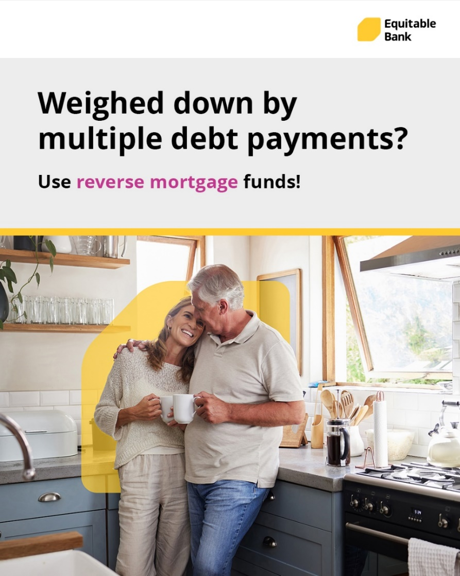

How to Post on Facebook
- Highlight, right-click, and press copy on the caption:

- Right-click and press save as picture on the image

- Login to your Facebook account and start a new post by clicking on ’What’s on your mind’

- Paste the caption. Don’t forget to add your contact information into the caption before posting

- Upload the image that you saved to the post

- Click Post

________________________________________________________________________________

How to Post on Instagram
- Highlight, right-click, and press copy on the caption

- Right-click and press save as picture on the image

- Login to your Instagram account and start a new post by clicking on the PLUS

- Upload the image that you saved to the post

- Click next and then next again

- Paste the caption. Don’t forget to add your contact information into the caption before posting

- Click Share

