Reverse Mortgage Social Media Post: Reverse mortgage myth vs reality
________________________________________________________________________________

Caption
One of the main pros of a reverse mortgage is you can use the funds however you choose.
That means you can pay out your conventional mortgage—releasing you from monthly payments.
Curious about how you can unlock financial peace of mind with a reverse mortgage?
Contact me at [your contact details] today.

Image
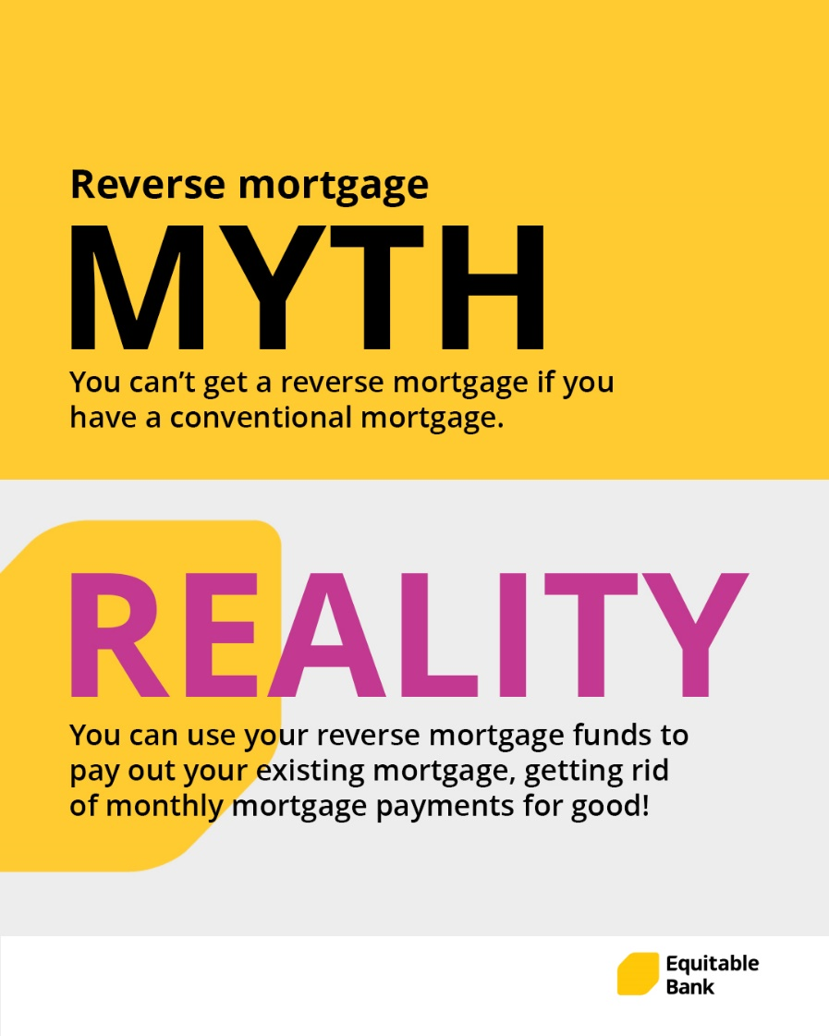

How to Post on Facebook
- Highlight, right-click, and press copy on the caption:

- Right-click and press save as picture on the image

- Login to your Facebook account and start a new post by clicking on ’What’s on your mind’

- Paste the caption. Don’t forget to add your contact information into the caption before posting

- Upload the image that you saved to the post

- Click Post

________________________________________________________________________________

How to Post on Instagram
- Highlight, right-click, and press copy on the caption

- Right-click and press save as picture on the image

- Login to your Instagram account and start a new post by clicking on the PLUS

- Upload the image that you saved to the post

- Click next and then next again

- Paste the caption. Don’t forget to add your contact information into the caption before posting

- Click Share

