First Home Savings Account Social Media Post: FHSA FAQs
________________________________________________________________________________

Note: The PDF file can be uploaded directly to LinkedIn. See below for instructions.
Feel free to edit captions to match your personal tone and add your own contact information.

LinkedIn Document Title: First Home Savings Account (FHSA) FAQs

Suggested Caption #1:
First time home buyers: curious about how a First Home Savings Account can help you reach your home ownership goals faster? Check out these FAQs about how this exciting new registered account works.
DM me if you have more questions about how to save for your first home!

Suggested Caption #2:
If you’re saving up for your first home, the First Home Savings Account is a useful tool that can help you achieve your goals. Click through the FAQs to learn more about what it is and how it works.

Suggested Caption #3:
Have you heard of the First Home Savings Account? This is a new tax-advantaged account specifically designed to help first time home buyers.
Want to learn more about the FHSA? Shoot me a message!

Hashtags: #FHSA #FirstHomeSavingsAccount #Homeownership #MortgageBroker #RealEstate

Post Mock-Up
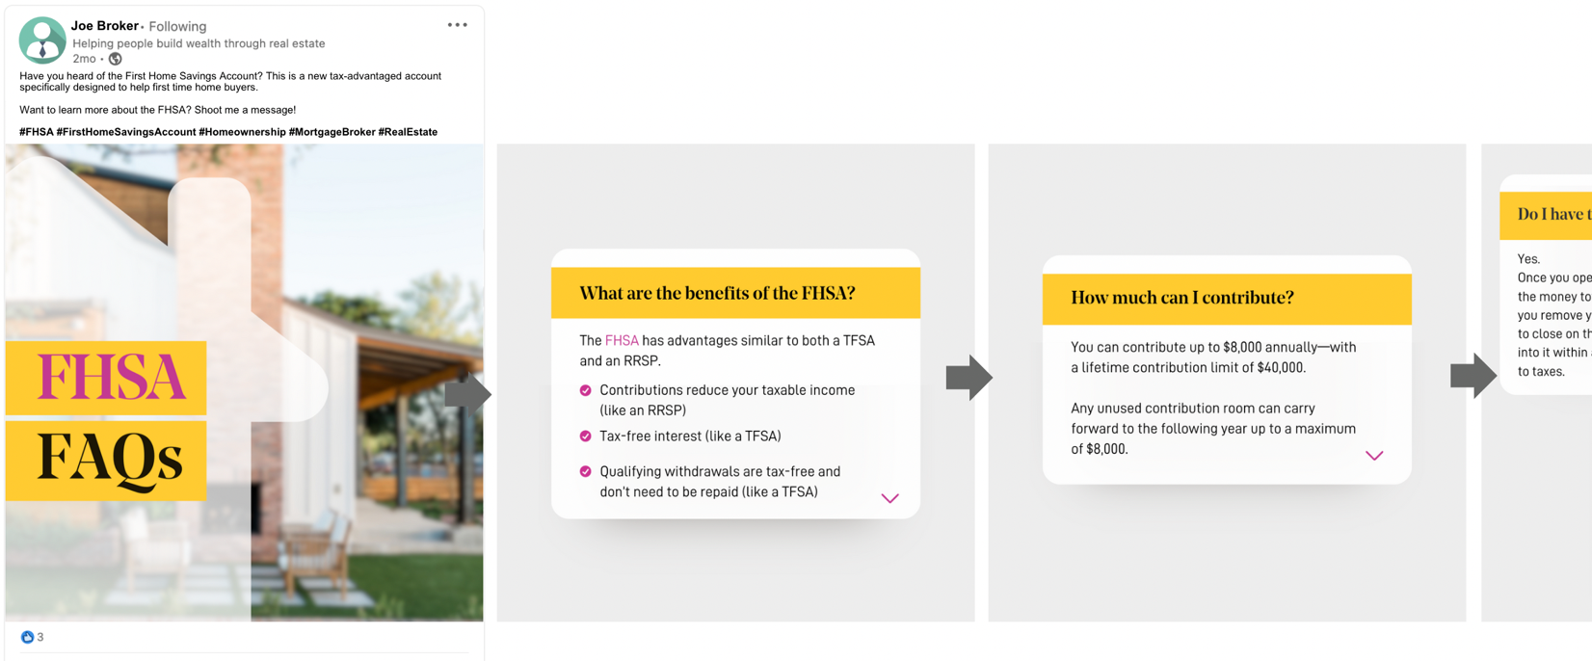
Note: actual post contains 11 slides to scroll through.

Visual Asset (Document)
For LinkedIn: Download the PDF from the Marketing Library
For Instagram: Download images in Zip File from the Marketing Library

How to Post a Document on LinkedIn
- Click Start a post in the sharebox at the top of your LinkedIn homepage.
- Click ••• More in the pop-up window, then click on the Add a document icon.
- Click Choose file to select a document from your computer.
  - You can also upload a document from the cloud, using the Dropbox or Google Drive options. You may encounter an alert that requires admin approval if you're using a corporate cloud account.
- Select the file that you want to upload (choose one).
- Add a title to your document and click Done.
- Add a description to the post.
  - You can use hashtags or @ to mention someone (Optional).
- Click Post.

